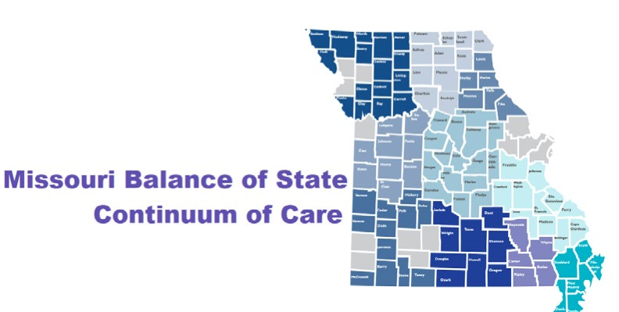
Missouri Balance of State CoC
Board of Director In-Kind Donation Form
Name:

Date:
Address:
Telephone:
____----
Email:
Description of donation (activity, amount of time, purpose, number of meetings):

Date range included in this form:
# of hours: Value of donation ($18.47/hour x # of hours): $
If a different value was used, explain:

Value of donation ($0.58 cents/mile x # of miles): $
Value of lodging (state rate): $
Initial each statement below verifying they are correct.
- My donated time listed above was not paid for with CoC funds. _ (initial)
- My donated time listed above was not used as match to another grant._ (initial)
By signing this form, I agree that everything listed above is true and correct to the best of my knowledge.
Signature: Date:

