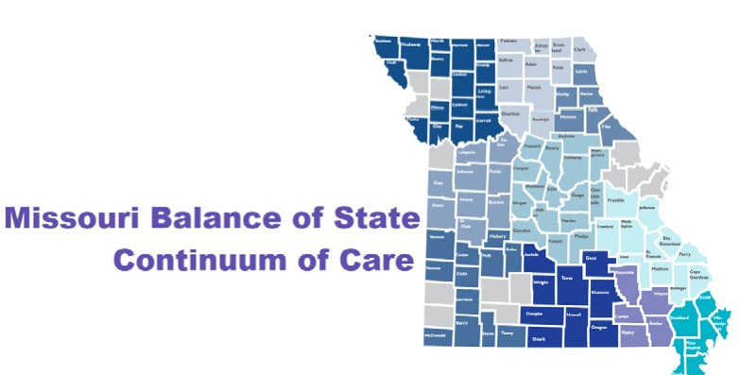
Missouri Balance of State CoC

Committee Volunteer Time Donation Form

Name: ______________________________________________

CoC Committee Name: _________________________

Address: ______________________________________

Telephone: _________________ Email: __________________________

Description of donation (activity, amount of time, purpose, number of meetings): _____ ______________________________________________________________________________

Date range included in this form: ___________

Number of hours: Value of donation ($18.47/hour x # of hours): $

If a different value was used, explain: _____________________________________

Value of mileage donation ($0.58 cents/mile x # of miles): $ __________
Value of lodging (state rate): $ ___________
Initial each statement below verifying they are correct.
My donated time listed above was not paid for with CoC funds. _ Y or N

My donated time listed above was not used as match to another grant Y or N

By signing this form, I agree that everything listed above is true and correct to the best of my knowledge.

Signature: ____________________ Date: ______________

Verification by Balance of State CoC Committee Chair

CoC Committee Chair Name: ______________________________

CoC Committee Name: _______________________________

Initial each statement below verifying they are correct.
As indicated above, this person participated in the committee for the amount of time indicated.
As the Committee chair, I confirm that the time donated was used in accordance with Continuum of Care planning activities listed in 24 CFR 578.39 (b). ______________________

By signing this form, I agree that everything listed above is true and correct to the best of my knowledge.

Signature: ____________________ Date: ___________________

