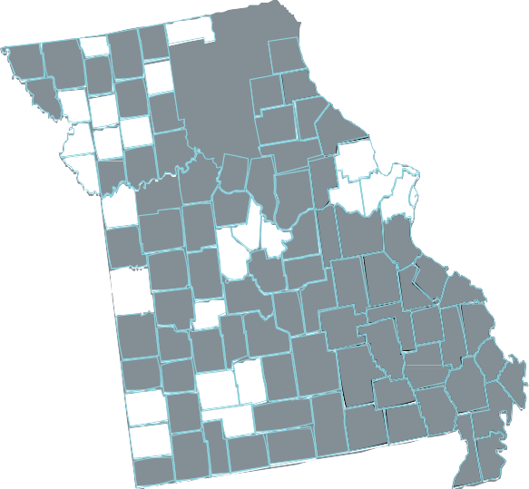
Mo BoS CoC
101 County Homelessness Survey

What?
Who?
Why?
How?
January 29, 2020
ANNUAL SHELTERED & UNSHELTERED HOMELESS POINT-IN-TIME COUNT
Point-In Time(PIT) Count is a survey of individuals or families sleeping in places not meant for human habitation or in emergency housing situations

Community providers, volunteers, businesses, faith-based organizations, people who are currently or have previously experienced homelessness, law enforcement, hospitals, and more

PIT Count provides an opportunity for communities to better understand the needs of community members experiencing homelessness

If you are interested in ﬁnding out more, visit:
www.moboscoc.org/pitcform

Get involved in your local PIT Count by contacting:

